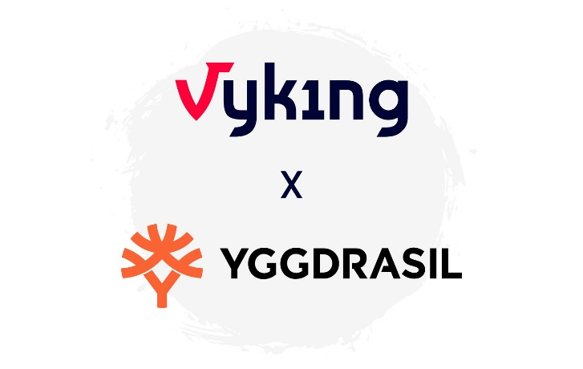
Vyking Expands Games Content Offering
with Full Yggdrasil Portfolio

Vyking, an iGaming platform provider and casino aggregator for fiat and crypto brands, has announced a new content partnership with Yggdrasil, making the supplier’s full portfolio, including its acclaimed YGG Masters titles, available to Vyking powered brands across Europe, Asia and Africa.

Franz Gerhart, CEO at Vyking, said:

Franz Gerhart, CEO at Vyking, added: “We are thrilled to announce this exciting partnership. Yggdrasil brings a well-known, high-quality portfolio and a steady pipeline of upcoming innovations that fit perfectly with our platform philosophy. This integration adds significant value for our partners, with access to a wide range of top-tier titles, including the 120+ games delivered each year by Yggdrasil’s network of 20+ Master Partners through one seamless integration”

The integration includes Yggdrasil’s complete game suite, from long-standing top-performers to new releases powered by its Game Engagement Mechanics (GEMs), as well as the full catalogue of 20+ YGG Masters studios contributing original, diverse, and market-focused content. For Vyking operators, this delivers instant access to a decade of proven slot innovation, supported by a pipeline of cutting-edge titles designed to engage and retain players across markets.

This new partnership enhances Vyking’s aggregation strategy, giving operators even more flexibility when curating their casino experience, all within Vyking’s open architecture, which supports white label, turnkey, and self-service deployment.

Jose Kadala, Chief Commercial Officer at Yggdrasil, added:

“Through this deal with Vyking we are able to reach an even wider audience, introducing our games to their network in numerous key markets. As a well-established supplier we are always looking for like-minded businesses who can ensure we deliver on our mission to bring the best entertainment to players around the world, and Vyking is the perfect partner.”

Vyking continues to grow its content aggregation layer with premium providers, giving operators the tools and content variety they need to differentiate, localize, and scale without platform constraints.
***ENDS***

About Vyking

Vyking is a future ready iGaming platform provider and games aggregator delivering white label, turnkey and self-service solutions for fiat and crypto brands. Founded in 2018 by a team of seasoned Austrian iGaming experts, Vyking enables operators to launch quickly, scale efficiently and retain full product ownership through open architecture, frontend access and modular tooling. Trusted by brands across Europe, Asia and Africa, Vyking supports long term growth through infrastructure built for scale and reliability.
Media Enquiries:
Robert.Connolly@vyking.com
www.vyking.com

